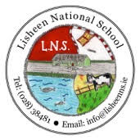

**Lisheen National School**

**ANNUAL ADMISSION NOTICE**

**in respect of admissions for the 2025/26 school year**

**Admission Policy and Application Form**

A copy of the school’s **Admission Policy**and the **Application Form for Admission**for the 2025/26 is available as follows: –

To download at:**www.lisheenns.ie**

On request: By emailing lisheen15563@gmail.com or calling 028 38481 or 0876030671

The following are the dates applicable for admission to junior infants.

|  |  |
| --- | --- |
| The school will commence accepting applications for admission on | Jan 30th |
| The school shall cease accepting applications for admission on | Feb 13th |
| The date by which applicants will be notified of the decision on their application is | Feb. 20nd |
| The period within which applicants must confirm acceptance of an offer of admission is**\*** | Feb 24th |

***Note: the school will consider and issue decisions on late applications in accordance with the school’s Admission Policy.***